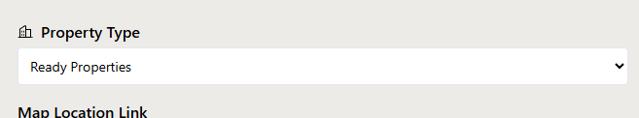
Ready Properties agr koi select karain to option ay
Apartment
Villas
Townhouse & More
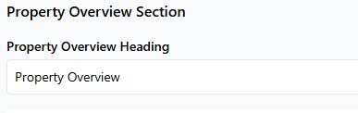
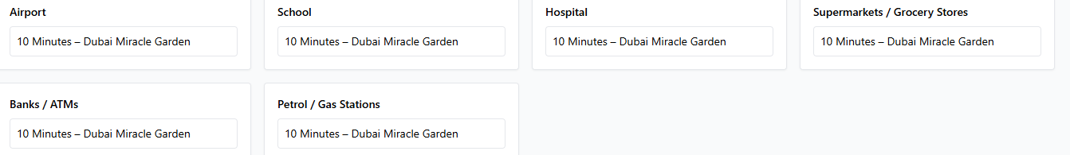
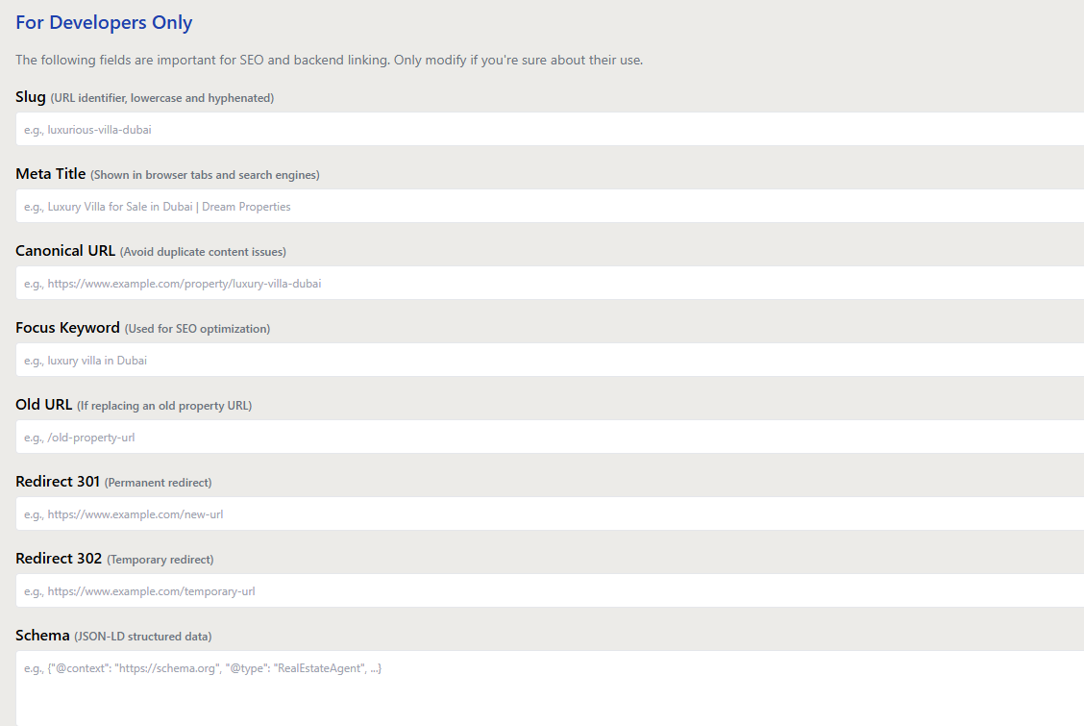
Property Overview ke heading fix kr dain, field he nahi show karwain.
Hamain agar multiple school yeh hopistal banks wagaira add krny hai to kaisay karain gy ap ny sirf 1 he box rakha howa hain.
These are the fields for SEO Section
Slug: use the property name in the slug ex: gharbi-2-residences/
Meta Title (60 Character): Use Property Name then Area or Community & Developer Name,
ex: Gharbi 2 Residences at JVC by Rabdan Developments
Meta Description (160 Character): Your focus keyword should be in the meta description and it should not be above then 160 character.
Canonical: use the property name in the slug ex: gharbi-2-residences/
Focus Keywords: Use the property name as focus keyword
These are fields for developer section
Old Redirect: not useful for the agents
Redirection 301: not useful for the agents
Redirection 302: not useful for the agents
Schema: not useful for the agents
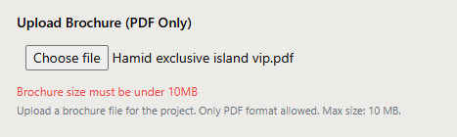

PDF File size should be under 20Mb’s

